The Inclusive Research Network is Looking for New Members

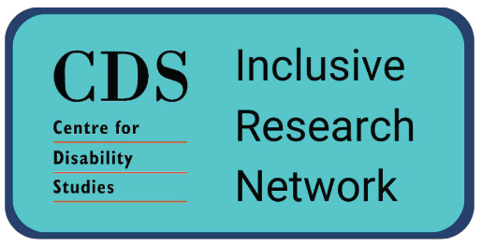 | The Inclusive Research Network is a group of people who do research together  We call it the IRN for short
 | In the IRN we have people with and without intellectual disability
 | We work together to do research projects about topics that affect people with intellectual disability
 | In our meetings we have discussions, listen to each other, socialise and have fun
 | It’s a great way to meet new people and learn new skills
 | We meet on the 4th Thursday of every month at 1:00 – 3:00 PM
Want to join the IRN?

Send an email to irn@cds.org.au

Tell us your name and why you want to join!

